

Practices for Secure Software Report

Table of Contents
Document Revision History 3
Client 3
Instructions 3
Developer 4
1. Algorithm Cipher 4
2. Certificate Generation 5
3. Deploy Cipher 5
4. Secure Communications 5
5. Secondary Testing 6
6. Functional Testing 7
7. Summary 8
8. Industry Standard Best Practices 8

Document Revision History

Version | Date | Author | Comments
1.0 | 10/17/2026 | Uri Naor

Client



Instructions

Submit this completed practices for secure software report. Replace the bracketed text with the relevant information. You must document your process for writing secure communications and refactoring code that complies with software security testing protocols.

- Respond to the steps outlined below and include your findings.
- Respond using your own words. You may also choose to include images or supporting materials. If you include them, make certain to insert them in all the relevant locations in the document.
- Refer to the Project Two Guidelines and Rubric for more detailed instructions about each section of the template.

Developer
Uri Naor

Algorithm Cipher

I recommend SHA-256. It is a widely used modern hash algorithm, so it’s a better fit than two-way encryption algorithms like the AES I chose in a previous assignment. It is mathematically irreversible, and changing a single character in the input completely transforms the result, so it’s perfect for our use case of detecting tampering. Also, it’s listed under the MessageDigest algorithms in Java Security Standard Algorithm Names (Oracle, n.d.), and listed under SHA-2 hash functions family, which are known to have no collisions.

The SHA-256 algorithm takes data (of any size) and turns it into a 256-bit hash. It is available through the built-in MessageDigest class, so we don’t need extra dependencies to use it. The hash is represented as a 64-character string represented by hexadecimal characters. I chose it over other algorithms listed under the MessageDigest class, such as MD2, MD5 and SHA-1 because they have proven hash collisions and I imagine they are listed as legacy support.

When it comes to bit levels, the bit level is the key size. This means that every bit added doubles the number of possible keys, so a 128 bit key has 2¹²⁸ possible combinations, while a 256-bit key has 2²⁵⁶. The difference is massive. If you know the Wheat and Chessboard Problem (Wikipedia contributors, 2026) then you’ll see that 2²⁵⁶ combinations means it’s practically impossible to brute force.

When it comes to hash functions, they’re a different beast, they are a one-way mathematical function that deterministically converts data into a fixed-length string. Because of that they can’t be used to encrypt files, but they’re still extremely useful when we want to verify data without knowing its true meaning.

Random numbers are used to create encryption keys. The reason we use random numbers is because if a key can be predicted, an attacker doesn’t need to break AES at all, they can just guess the key. That’s why keys should be generated with random numbers that can’t be guessed. As for keys, symmetric means that the same secret key is used to both encrypt and decrypt, which is what keeps the process fast even on big archive files. Non-symmetric (asymmetric) encryption uses pairs of keys instead - meaning a public key is used to encrypt and a private key is used to decrypt (Manico & Detlefsen, 2014).

Encryption has always been a race between the people that are making ciphers and the people that are trying to break them. For example, the DES cipher used to be the standard back in the day, but as computers got faster, its 56-bit key was able to be brute forced. To counter, Triple DES emerged, which is essentially just the DES algorithm applied three times in succession, however nowadays it’s also considered obsolete. A modern alternative is the AES cipher. It is considered strong, fast and secure, and it hasn’t been broken.

Some algorithms have known collisions that were discovered through finding a mathematical weakness, allowing attackers to craft collisions using chosen-prefix techniques and so on. When that happens it means the algorithm is no longer safe, as attackers could create malicious documents that result in the same hash as safe ones. Because of that we should always stick to choosing ciphers that don’t have any known collisions. And it is the exact reason the SHA-3 family was developed (to have an alternative in the case that the SHA-2 family ciphers will break).

Certificate Generation
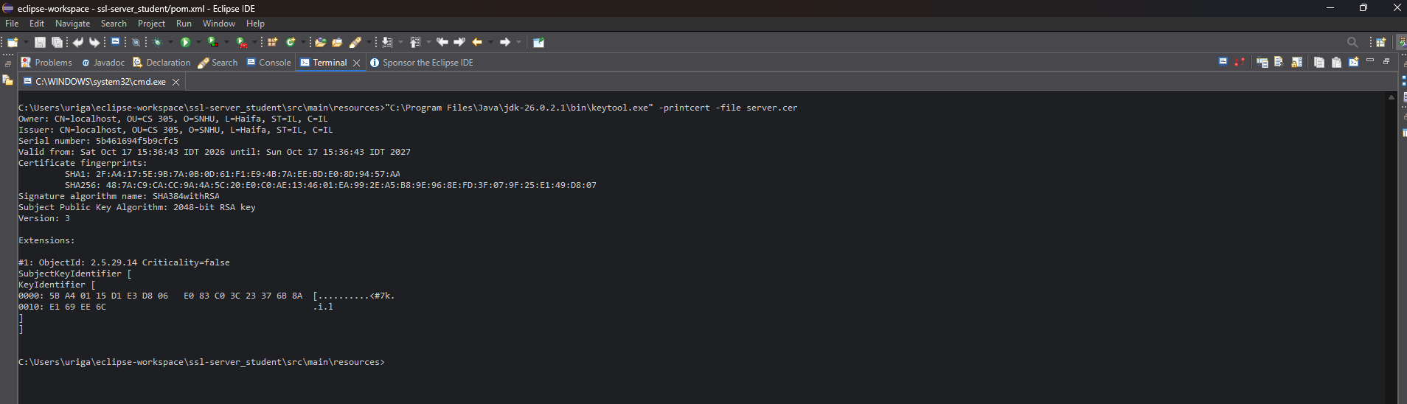

I generated a self-signed certificate using the Java Keytool from the cmd terminal in Eclipse and stored it in keystore.p12 with the alias “artemis”, and exported it as server.cer. The printout shows that the owner and the issuer are both CN=localhost.

Deploy Cipher
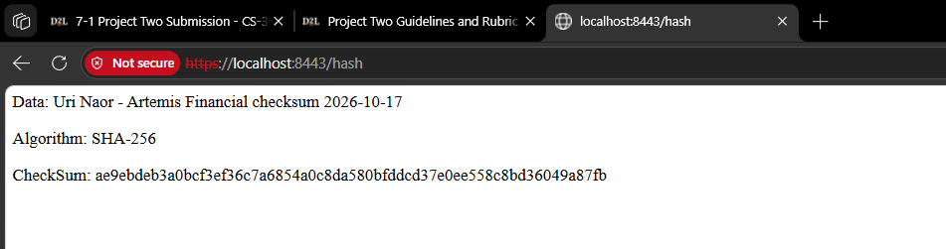

I added a /hash route to SslServerApplication.java that runs my unique data string through SHA-256 using Java’s built-in MessageDigest class.

Secure Communications
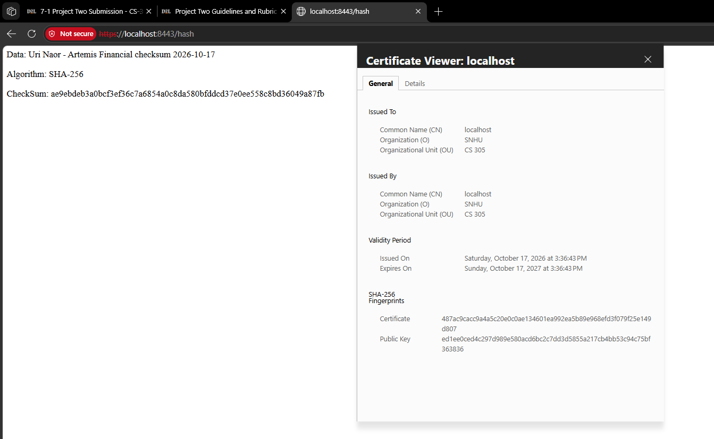

I added SSL settings along with a certificate so that traffic between the client and the server is encrypted. It’s marked as “Not secure” because while certificates from a CA are trusted by browsers immediately (Let’s Encrypt, 2025), self-signed certificates aren’t trusted on their own (and for a good reason).

Secondary Testing
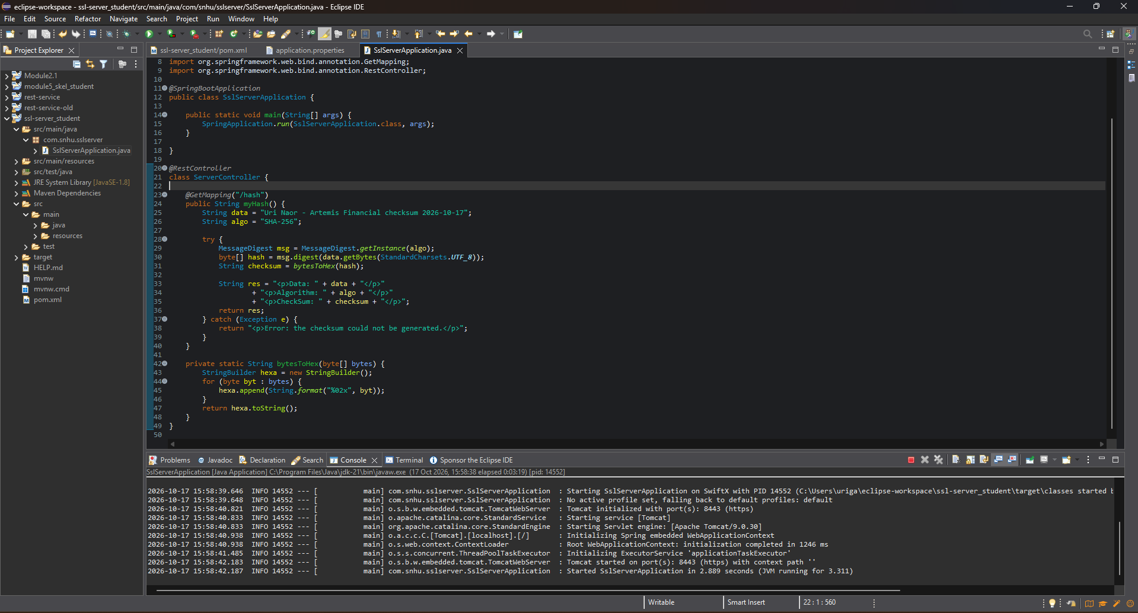
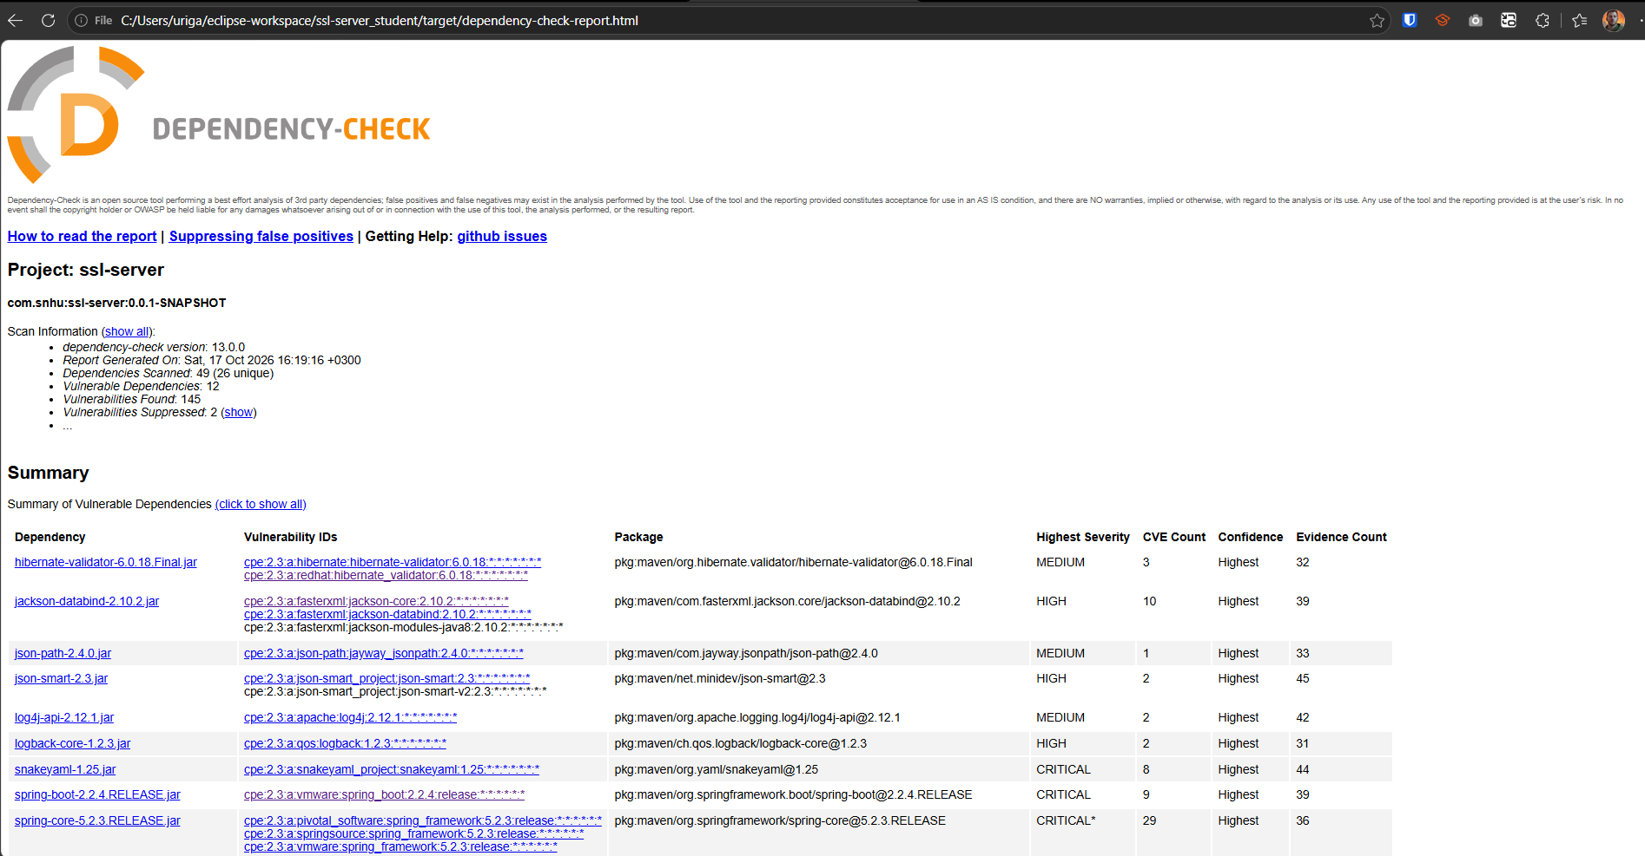

According to the scan information there were 49 dependencies scanned, 26 of which were unique. Out of those, there were 12 vulnerable dependencies, and overall 145 vulnerabilities found.

The only code I added uses Java’s built-in MessageDigest class, so I didn’t add any new dependencies. All of the vulnerable dependencies in the report come from the Spring Boot starters that were already in the original pom.xml, which means the refactoring didn’t introduce any new vulnerabilities.

In summary, the project inherits from spring-boot-starter-parent 2.2.4.RELEASE, which dates to early 2020 (Maven Repository: org.springframework.boot » Spring-boot-starter-parent » 2.2.4.RELEASE, 2020), and decides the versions of its dependencies. This means that the versions of Tomcat, Spring, Jackson, SnakeYAML, Logback, and Hibernate Validator that the scan flagged, can all be updated by simply updating the version of the dependency declared in the pom file. This would be the single most effective way to clear most of the 145 vulnerabilities.

Functional Testing
(same screenshot as in section 5).

I didn’t find any syntax errors, and the refactored code now compiles and runs with no errors as shown in the screenshot.

However, when I manually reviewed the original code I did find a few issues:

- Nothing had set up HTTPS. From looking around I found the config file application.properties, but it just had a port number and “????” placeholders for the SSL settings, which I filled, causing the app to run on HTTPS instead of plain HTTP.
- There was initially no /hash route so there was no way to generate a checksum. I then added a controller with the /hash route.
- If the hashing code would throw an exception, it could have shown a stack trace with internal details. I put it in a try/catch block that returns a short error message to protect against that.
- The dependency-check plugin in pom.xml was version 5.3.0, which is quite old so I updated it to version 13.0.0 so I could work with my NVD API key.

Summary

When it comes to this specific app, which is a relatively small Spring Boot web app that exposes a /hash endpoint, the areas I addressed by refactoring the code are APIs, Cryptography, Code Error and Code Quality.

APIs (Secure API Interactions): This application is basically just one HTTP endpoint, so the API is the entire attack surface. The /hash endpoint now only runs over HTTPS and only answers GET requests.

Cryptography (Encryption Use and Vulnerabilities): Since this is a company that handles sensitive financial data, I figured that HTTPS should be enabled across all endpoints. So I enabled HTTPS with a self-signed certificate and added SHA-256 checksum to verify the data.

Code Error (Secure Error Handling): The app should handle errors gracefully and make sure to not show internal details like an error stack trace. That’s why the hashing code is wrapped in a try/catch that only returns a short error message.

Code Quality (Secure Coding Practices / Patterns): The code should use safe practices, such as avoiding outdated libraries, and keeping third-party dependencies safe. I used Java’s built-in MessageDigest which didn’t add a new dependency, and made sure to update and run the dependency-check plugin to confirm no new vulnerabilities were added.

As there’s no client side, I don’t think that Client / Server applies here, and the Encapsulation seems fine to me. The /hash endpoint currently doesn’t take any input so Input Validation is also irrelevant here.

As for my process for adding layers of security, I view it as a step-by-step process of building them one on top of the other, so that if one layer fails, the others still protect the data. For example, in this case, the HTTPS encrypts the data, so a person sitting in the middle of the connection won’t be able to read it. Then for another layer the SHA-256 checksum lets Artemis verify that the data wasn’t changed.

Other security measures include that errors are handled without leaking internal details and I made sure vulnerabilities in general are minimized by running the dependency check and manually reviewing the code to make sure that the refactoring didn’t add any new security issues.

Industry Standard Best Practices

When refactoring I tried to follow industry standard practices to make sure the existing security stays intact. For example, I chose SHA-256 from Java’s built-in library instead of picking an outdated algorithm or using a third-party library. Third-party libraries and dependencies can be a big threat as they add another “puzzle-piece” that needs to be monitored, so an industry standard is to minimize the use of external libraries where possible, which is what made the use of Java’s built-in library a great choice. Another industry standard is using HTTPS for all pages, so I enabled HTTPS as it’s assumed everywhere nowadays.

Now regarding the value of security, security is always valuable to any company, but especially in the case of Artemis. Since Artemis Financial is a consulting company that develops individualized financial plans for its customers like savings, retirement, investments, and insurance, it means that they handle very sensitive personal information. As a financial company, we can say that in essence they are in the business of earning their customer’s trust.

Because of that, security has a major and direct impact on their business. For example, if any personal or financial details of their customers leak, or worse, get modified in any way, this could have a major impact on both the customer and the reputation of the company, and possibly even get the attention of media companies and the news.

I found that Artemis has to follow the Gramm-Leach-Bliley Act (GLBA), as the official guidelines say: “The Gramm-Leach-Bliley Act requires financial institutions – companies that offer consumers financial products or services like loans, financial or investment advice, or insurance – to explain their information-sharing practices to their customers and to safeguard sensitive data.” (Gramm-Leach-Bliley Act, 2026). Therefore securing the data isn’t a nice-to-have, it’s a must.

References

Gramm-Leach-Bliley Act. (2026, February 13). Federal Trade Commission. https://www.ftc.gov/business-guidance/privacy-security/gramm-leach-bliley-act

Let's Encrypt. (2025, August 2). How it works. https://letsencrypt.org/how-it-works/

Manico, J., & Detlefsen, A. (Sep 2014). O’Reilly Media - Technology and Business training. O’Reilly Online Learning. https://learning.oreilly.com/library/view/iron-clad-java/9780071835886/?sso_link=yes&sso_link_from=SNHU

Maven Repository: org.springframework.boot » spring-boot-starter-parent » 2.2.4.RELEASE. (2020, January 20). https://mvnrepository.com/artifact/org.springframework.boot/spring-boot-starter-parent/2.2.4.RELEASE

Oracle. (n.d.). Java security standard algorithm names. Oracle Help Center. https://docs.oracle.com/javase/9/docs/specs/security/standard-names.html#messagedigest-algorithms

Wikipedia contributors. (2026, June 7). Wheat and chessboard problem. Wikipedia. https://en.wikipedia.org/wiki/Wheat_and_chessboard_problem

